KLS Gogte Institute of Technology
Department of Computer Science & Engineering
Subject : Problem solving with C Code : 18CCP14

Assignment I – Open Book
Semester : I Div : K Date : 18/01/2021
Max. Marks : 10
- Analyze the code segment and find the write the output. [L3 ][CLO1] [PO1]  Void main( )  {  float x=1.23;  int sum;  sum = (int)x + 1;  printf(“%d” , sum);  }  - Evaluate the given expression a=20 b=10 c= 15 d=5 , e=(a+b) * c / d  [L3 ][CLO1] [PO1]  - DESIGN A C PROGRAM TO READ YOUR NAME , DIVISION , MOBILE NUMBER , ADDRESS , COLLEGE , BRANCH ,MARKS OBTAINED IN 3 SUBJECTS AND MOBILE NUMBER AND HENCE DISPLAY THE SAME ,COMPUTE AVERAGE OF ALL THE 3 MARKS DISPLAY THE RESULT. [L3][CLO1][PO1]  - Analyze the code and identify the errors. [L2][CLO2][PO1]  $include STDIO  Main [ ]  {  Int a , b , sum;  A=10 ,b=20;  Sum = a+b;  Printf( sum= “ , sum)  }  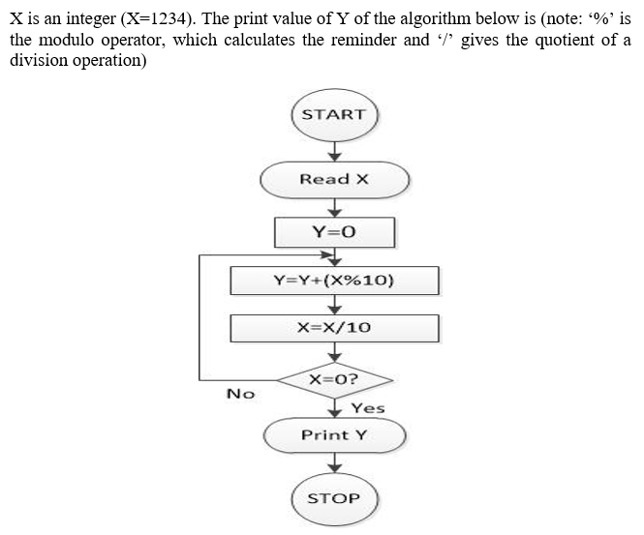  [L3][CLO2][P03] 2M | 2M  2M  2M  2M
Class Strength :
No. of students participated (submitted) :

Reviewed on :

IQAC Auditor’s Signature Faculty Name : Mrs.Sudha V S HOD
Sign:

KLS Gogte Institute of Technology
Department of Information Science & Engineering
Subject : Programming with C Code : 18CCP24

Assignment I – Open Book - SCHEME
Semester : II Div : F Date : 05.02.2019
Max. Marks : 10
1

Class Strength :
No. of students participated (submitted) :

Reviewed on :

IQAC Auditor’s Signature Faculty Name : Mrs.Sudha H Ayatti Signature

